How to Share your BMW photos with the Allegheny Chapter
- Navigate to the Allegheny Chapter site:
  - http://alleghenybmwcca.org/

- Click on the “SUBMIT PHOTOS” link on the top left of the site:
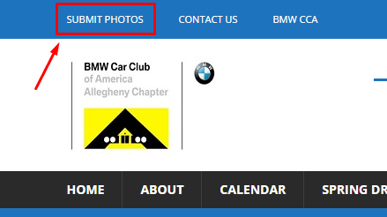

- Next click on the “SUBMIT” button:
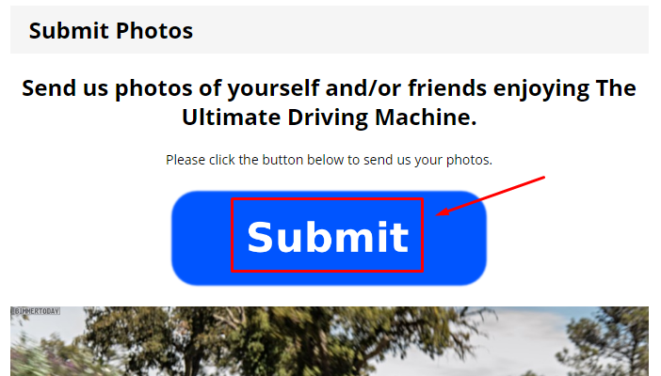

- Then click on the button that says “Choose files”: 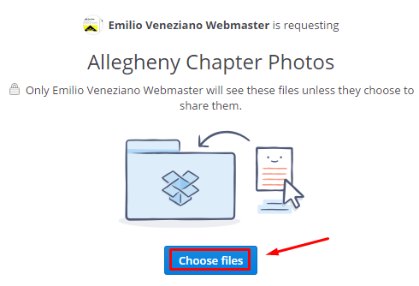
- Next you can select the images that you want to upload then click “Open”:

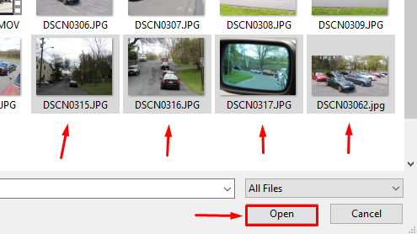

- Once your photos are select, enter your First and Last name and email address, then click “Upload 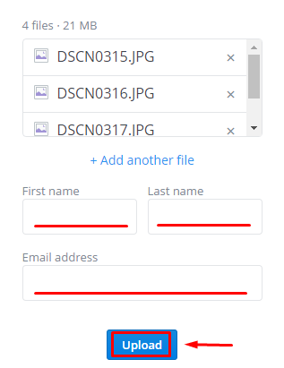
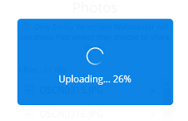
- Once the upload is complete, you can close out of the Internet browser and do not need to create an account.

